Practice No.3

import numpy as np

import matplotlib.pyplot as plt

import seaborn as sns

sns.set()

from matplotlib.colors import ListedColormap

from sklearn.datasets import make_gaussian_quantiles

cmap_light = ListedColormap(['#FFAAAA', '#AAAAFF'])

cmap_bold = ListedColormap(['#FF0000', '#0000FF'])

N = 500

X, Y = make_gaussian_quantiles(mean=None, cov=0.5, n_samples = N,

n_features = 2, n_classes=2, shuffle = True,

random_state = 42)

X = X.T

Y = Y.reshape(1, len(Y))

print(X.shape)

print(Y.shape)

plt.figure(figsize = (10, 6))

plt.scatter(x = X[0, :], y = X[1, :], c = Y, s = 30, cmap = plt.cm.Spectral);

plt.xlabel("$X_1$")

plt.ylabel("$X_2$")

plt.show()

def sigmoid(z):

sigmoid = 1 / (1 + np.exp(-z))

return sigmoid

def tanh(z):

tan = (np.exp(z) - np.exp(-z)) / (np.exp(z) + np.exp(-z))

return tan

def layer_sizes(X, Y):

"""

Returns:

n_x -- size of the input layer

n_h -- size of the hidden layer

n_y -- size of the output layer

"""

n_x = X.shape[0]

n_h = 4

n_y = Y.shape[0]

return n_x, n_h, n_y

def initialize_params(n_x, n_h, n_y):

W1 = np.random.randn(n_h, n_x) * 0.01

b1 = np.zeros((n_h, 1))

W2 = np.random.randn(n_y, n_h) * 0.01

b2 = np.zeros((n_y, 1))

return W1, b1, W2, b2

def forward_propagation(X, W1, b1, W2, b2):

Z1 = np.dot(W1, X) + b1

A1 = tanh(Z1)

Z2 = np.dot(W2, A1) + b2

A2 = sigmoid(Z2)

return Z1, A1, Z2, A2

def compute_cost(Y, A2):

m = Y.shape[1]

cost = (-1/m) * np.sum(np.multiply(Y ,np.log(A2)) + np.multiply((1-Y), np.log(1-A2)))

cost = float(np.squeeze(cost))

return cost

def backward_propagation(X, Y, W1, b1, W2, b2, Z1, A1, Z2, A2):

m = X.shape[1] # Number of training examples

dZ2 = A2 - Y

dW2 = (1/m) * np.dot(dZ2, A1.T)

db2 = (1/m) * (np.sum(dZ2, axis = 1, keepdims = True))

dZ1 = np.dot(W2.T, dZ2) * (1 - np.power(A1, 2))

dW1 = (1/m) * (np.dot(dZ1, X.T))

db1 = (1/m) * (np.sum(dZ1, axis = 1, keepdims = True))

return dW1, db1, dW2, db2

def update_params(W1, b1, W2, b2, dW1, db1, dW2, db2, learning_rate):

W1 = W1 - learning_rate * dW1

b1 = b1 - learning_rate * db1

W2 = W2 - learning_rate * dW2

b2 = b2 - learning_rate * db2

return W1, b1, W2, b2

def neural_network(X, Y, n_h, learning_rate, num_iterations = 500):

n_x = layer_sizes(X, Y)[0]

n_y = layer_sizes(X, Y)[2]

costs = []

# Initialize parameters

W1, b1, W2, b2 = initialize_params(n_x, n_h, n_y)

# Loop (gradient descent)

for i in range(0, num_iterations):

Z1, A1, Z2, A2 = forward_propagation(X, W1, b1, W2, b2)

cost = compute_cost(Y, A2)

if i % 10 == 0:

costs.append(cost)

dW1, db1, dW2, db2 = backward_propagation(X, Y, W1, b1, W2, b2, Z1, A1, Z2, A2)

W1, b1, W2, b2 = update_params(W1, b1, W2, b2, dW1, db1, dW2, db2, learning_rate)

return W1, b1, W2, b2, costs

def predict(W1, b1, W2, b2, X):

Z1, A1, Z2, A2 = forward_propagation(X, W1, b1, W2, b2)

m = X.shape[1]

y_pred = np.zeros((1, m))

for i in range(A2.shape[1]):

if A2[0, i] >= 0.5:

y_pred[0, i] = 1

else:

y_pred[0, i] = 0

return y_pred

def plot_decision_boundary(model, X, Y):

# Set min and max values and give it some padding

x_min, x_max = X[0, :].min() - 1, X[0, :].max() + 1

y_min, y_max = X[1, :].min() - 1, X[1, :].max() + 1

h = 0.01

# Generate a grid of points with distance h between them

xx, yy = np.meshgrid(np.arange(x_min, x_max, h), np.arange(y_min, y_max, h))

# Predict the function value for the whole grid

Z = model(np.c_[xx.ravel(), yy.ravel()])

Z = Z.reshape(xx.shape)

# Plot the contour and training examples

plt.figure(figsize = (10, 6))

plt.contourf(xx, yy, Z, cmap=cmap_light)

plt.ylabel('x2')

plt.xlabel('x1')

plt.scatter(X[0, :], X[1, :], c = Y, cmap=plt.cm.Spectral)

W1, b1, W2, b2, costs = neural_network(X, Y, n_h = 1, learning_rate= 1, num_iterations= 1000)

plot_decision_boundary(lambda x: predict(W1, b1, W2, b2, x.T), X, Y)

plt.figure(figsize = (10, 6))

plt.title('Cost Function')

plt.xlabel('No. of iterations')

plt.ylabel('Cost')

plt.plot(range(1, 1001, 10), costs)

plt.show()

predictions = predict(W1, b1, W2, b2, X)

accuracy = float((np.dot(Y, predictions.T) + np.dot(1-Y,1-predictions.T))/float(Y.size) * 100)

print (f'Accuracy: {round(accuracy, 2)} %')

Output:-

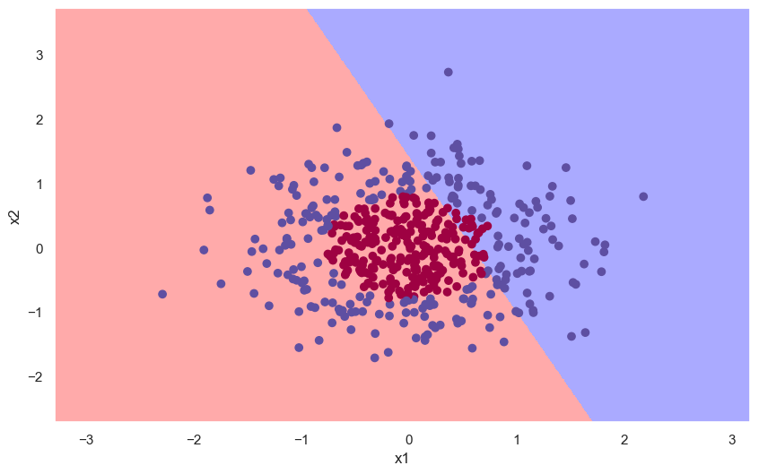

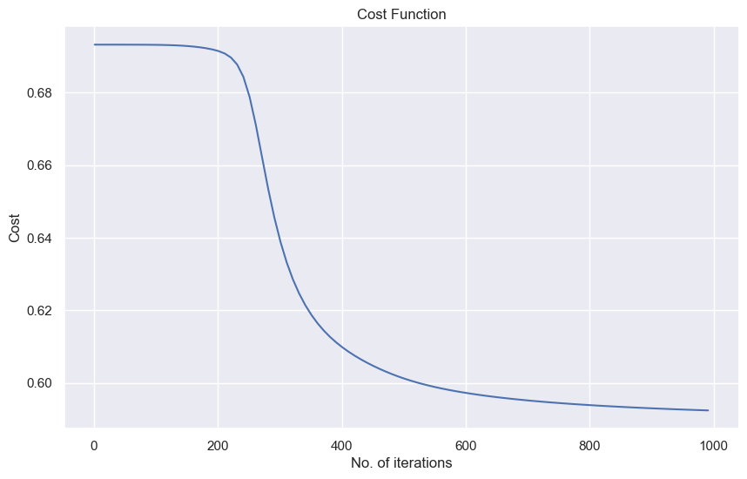

Accuracy: 64.6 %